AI ASSISTED CODING (ASSIGNMENT-3.1)
NAME: V.Madhav Reddy
BATCH NO: 24
ROLL NO: 2503A52698

Q1. Zero-Shot Prompting (Palindrome Number Program)
Write a zero-shot prompt (without providing any examples) to generate a Python function that checks whether a given number is a palindrome.
Task:
- Record the AI-generated code.
- Test the code with multiple inputs.
- Identify any logical errors or missing edge-case handling.

Prompt: give a python code to check whether the number is palindrome or not
Code:
number = input("Enter a number: ")
if number == number[::-1]:
print("The number is a palindrome.")
else:
print("The number is not a palindrome.")
output:
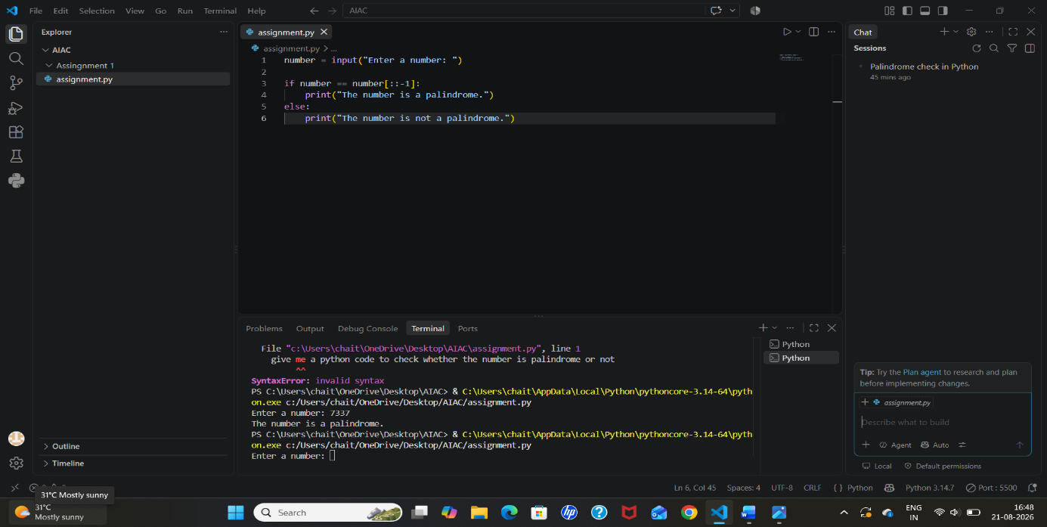

Q2. One-Shot Prompting (Factorial Calculation)
Write a one-shot prompt by providing one input-output example and ask the AI to generate a Python function to compute the factorial of a given number.
Example:
Input: 5 → Output: 120
Task:
- Compare the generated code with a zero-shot solution.
- Examine improvements in clarity and correctness.
Prompt: generate a python code to calculate the factorial of a given number
Code:
number = int(input())
factorial = 1
for value in range(1, number + 1):
factorial *= value
print(factorial)
output:
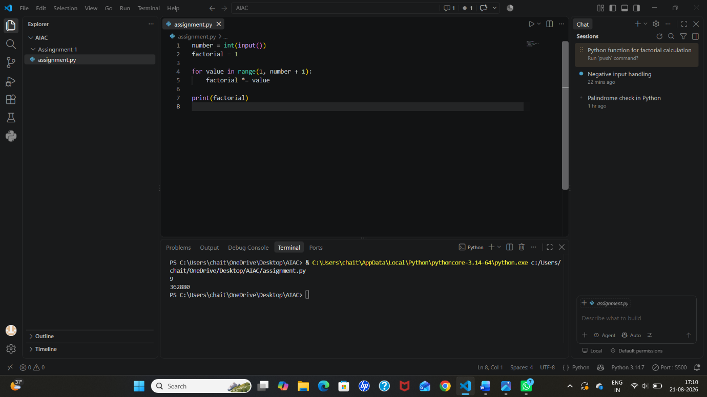

Q3. Few-Shot Prompting (Armstrong Number Check)
Write a few-shot prompt by providing multiple input-output examples to guide the AI in generating a Python function to check whether a given number is an Armstrong number.
Examples:
- Input: 153 → Output: Armstrong Number
- Input: 370 → Output: Armstrong Number
- Input: 123 → Output: Not an Armstrong Number
Task:
- Analyze how multiple examples influence code structure and accuracy.
- Test the function with boundary values and invalid inputs.
Promt: give a python code to check whether a number is Armstrong number or not.
Code:
number = int(input("Enter a number: "))
digits = str(number)
power = len(digits)
sum_of_powers = sum(int(digit) ** power for digit in digits)
if sum_of_powers == number:
print("Armstrong number")
else:
print("Not an Armstrong number")
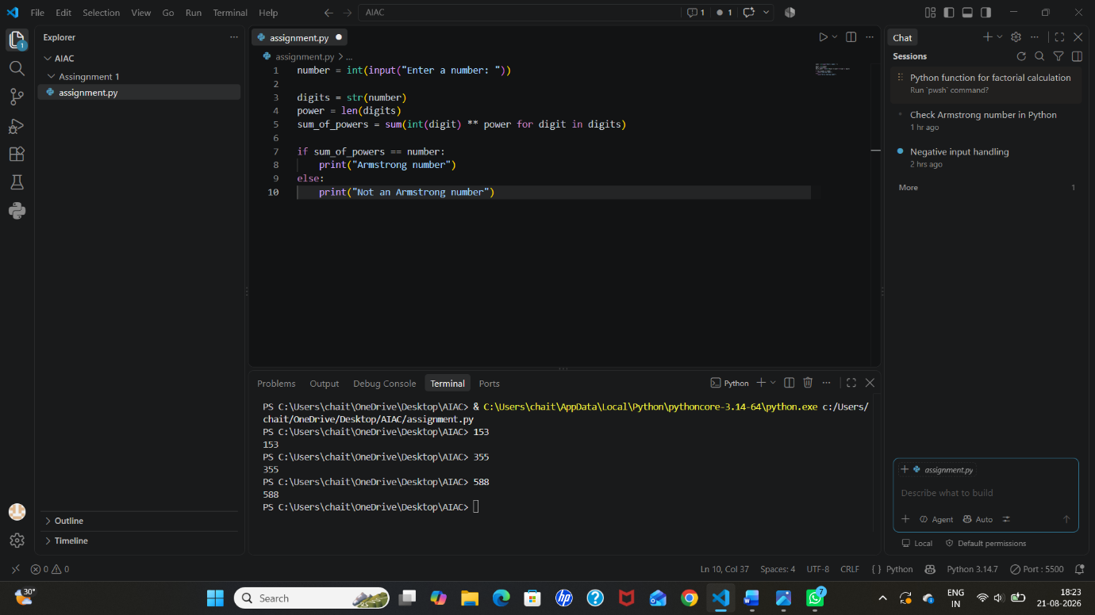

Q4. Context-Managed Prompting (Optimized Number Classification)
Design a context-managed prompt with clear instructions and constraints to generate an optimized Python program that classifies a number as prime, composite, or neither.
Task:
- Ensure proper input validation.
- Optimize the logic for efficiency.
Compare the output with earlier prompting strategies
Prompt: give a python code to classifies a number as prime, composite or neither
Code:
import math
def classify_number(number):
if number<2:
return "neither"
for divisor in range(2, math.isqrt(number) + 1):
if number % divisor == 0:
return "composite"
return "prime"
number = int(input("Enter a number: "))
print(classify_number(number))
output:
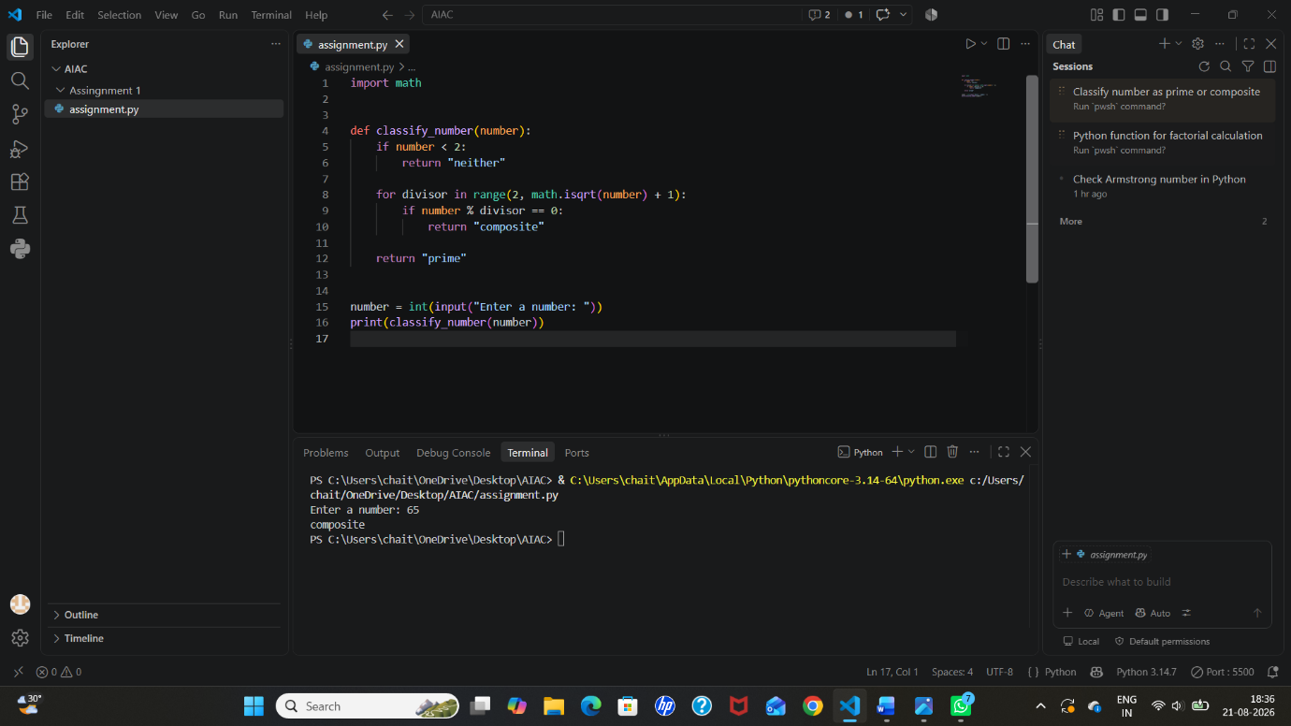

Q5. Zero-Shot Prompting (Perfect Number Check)
Write a zero-shot prompt (without providing any examples) to generate a Python function that checks whether a given number is a perfect number.
Task:
- Record the AI-generated code.
- Test the program with multiple inputs.
- Identify any missing conditions or inefficiencies in the logic.
Prompt: give a python code to check whether a given number is a perfect number or not.
Code:
number = int(input("Enter a number: "))
divisor_sum = sum(
divisor for divisor in range(1, number)
if number % divisor == 0
)
if divisor_sum == number:
print("Perfect number")
else:
print("Not a perfect number")
output:
